Assessment – Gamertag Project

This assessment includes the following:
- Clarify the task and understand the project requirements,
- Identify the expected specifications, standards and guidelines for the project
- Create a console-based application that loads from file a list of gamertags and presents the information on screen in a variety of ways
- Create and conduct simple tests and confirm code meets design brief
- Documenting actions carried out and results of tests performed

Complete this document and submit as part of your final assessment.

Contents
Task Description 3
Expected Output 3
Identify Standards and Guidelines 4
Step 1 – Answer each statement by selecting True/False 4
Step 2 – Identify one other Programming Standard/Guideline 5
Getting Started 6
Step 1 – Download the AIE template project 6
Step 2 – Unzip the file to your chosen working folder 6
Step 3 – Open the Visual Studio solution 6
Console-based Program 7
Step 1 - Create a Gamertags class 7
Step 2 - Loading the “Gamertags.txt” file via the Gamertags class 8
Step 3 – Printing all available gamertags 10
Step 4 – Create an instance of the Gamertag class 11
Step 5 – Test your current progress 12
Step 6 – Filter and Display gamertags ending with a number 13
Step 7 - Filter and Display gamertags NOT starting with a “letter or number” 14
Step 8 – Display a Welcome Message 15
Step 9 – Processing user input 16
Step 10 (Optional) – Create other filters for gamertags 16
Step 11 (Optional) – Getting creative 16
Debugging Exercise 17
Step 1 - Answer the following questions about debugger usage 17
Final Testing 18
Step 1 – Perform the following tests and record the results 18
Step 2 – Fix any errors in your program before submitting your assignment 18

Task Description

In this assignment you will:
- Create a console application that
- Loads from file a list of Gamertags, and
- Displays information about the Gamertags to the console in several ways as described in the “Console-based Gamertag program” section below
The program will be:
- Written in the C# programming language
- Using the Visual Studio IDE (Integrated Development Environment)

Read through these instructions to understand what’s required from your application and what expected output is to be presented.

Expected Output
The following screenshot is an example of some expected output from your completed program.
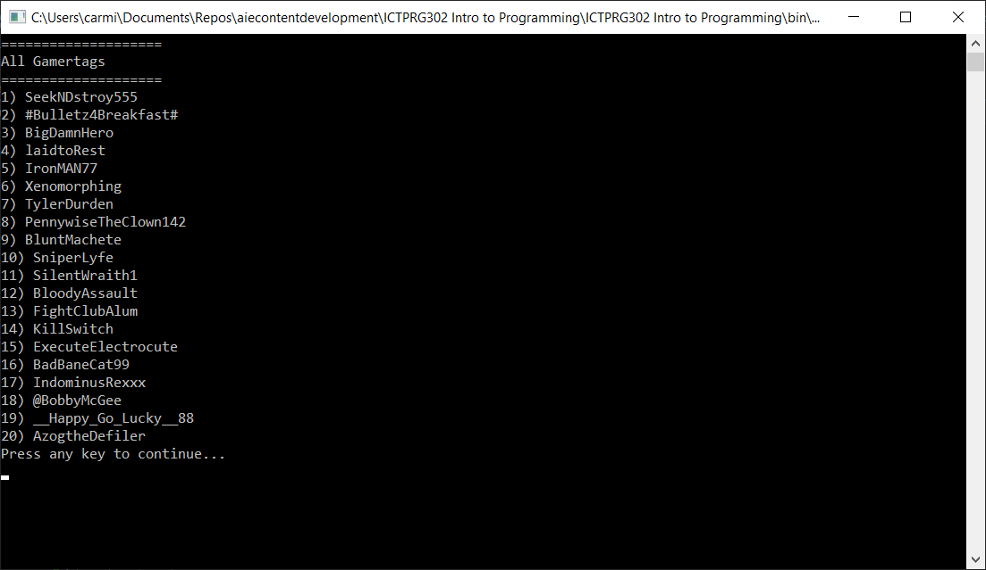

Identify Standards and Guidelines
Programming Standards, Conventions and Guidelines aim to provide programmers with a recommended, consistent set of rules to facilitate code maintenance, increase readability and reduce the opportunity for the bugs. There are several available on the internet by large companies and foundations. Often teams will create a custom set of guidelines for their specific project(s).

Step 1 – Answer each statement by selecting True/False

 | Which of the following statements are True? | True/False?
1 | The following Capitilization Guidelines, which form part of the Microsoft Framework Design Guidelines:  - Recommend simple & consistent rules for using case that  - Make identifiers for types, members, and parameters easy to read  https://docs.microsoft.com/en-us/dotnet/standard/design-guidelines/capitalization-conventions | TRUE
2 | The following MSDN General Naming Conventions recommends:  - Favouring brevity over readability when naming variables, classes and properties. Implying that short, unreadable names are better than longer names that are readable and easily understandable  - Using of hungarian notation for identifier names  - Using abbreviations whenever possible  https://docs.microsoft.com/en-us/dotnet/standard/design-guidelines/general-naming-conventions | FALSE
3 | The following MSDN C# Standards & Guidelines aim to:  - Create a consistent look to the code  - Enable readers to understand the code more quickly  - Facilitate copying, changing, and maintaining the code  - Demonstrate C# best practices  https://docs.microsoft.com/en-us/dotnet/csharp/programming-guide/inside-a-program/coding-conventions | TRUE
4 | The following MSDN Layout Conventions aim to:  - Encourage programmers to express their individual style  - Make it difficult to read the code  - Make the code harder to maintain  https://docs.microsoft.com/en-us/dotnet/csharp/programming-guide/inside-a-program/coding-conventions#layout-conventions | FALSE
5 | The following MSDN Field Design recommends:  - Using constant fields for values that will never change  https://docs.microsoft.com/en-us/dotnet/standard/design-guidelines/field | TRUE

Step 2 – Identify one other Programming Standard/Guideline

- Using the following URL as a starting point:
  - https://docs.microsoft.com/en-us/dotnet/standard/design-guidelines/
- Select one section, then identify a recommended guideline contained in it.
- Document the recommendations below

Copy/Paste the URL of your selected MSDN Programming Standard/Guideline
Abstract Class Design - Framework Design Guidelines | Microsoft Learn

Describe one positive recommendation from the selected URL
✔️ DO define a protected or an internal constructor in abstract classes.

Describe one negative recommendation guideline from the selected URL
❌ DO NOT define public or protected internal constructors in abstract types.

Getting Started
A starting Visual Studio project is provided on AIE Canvas. It includes the starting files necessary to complete this assignment.

Step 1 – Download the AIE template project
Download the starting project named “ICTPRG302 Intro to Programming.zip” from Canvas to your computer.

Step 2 – Unzip the file to your chosen working folder
Unzip the file to your working folder of choice.
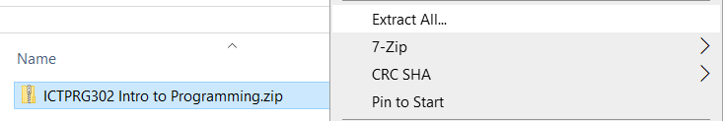

Step 3 – Open the Visual Studio solution
Several files and folders will be unzipped to your selected location, including the Visual Studio solution file, called “ICTPRG302 Intro to Programming.sln”
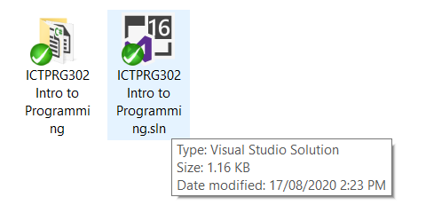
Double-click the “ICTPRG302 Intro to Programming.sln” file to open it in Visual Studio. You should be presented with something like this:
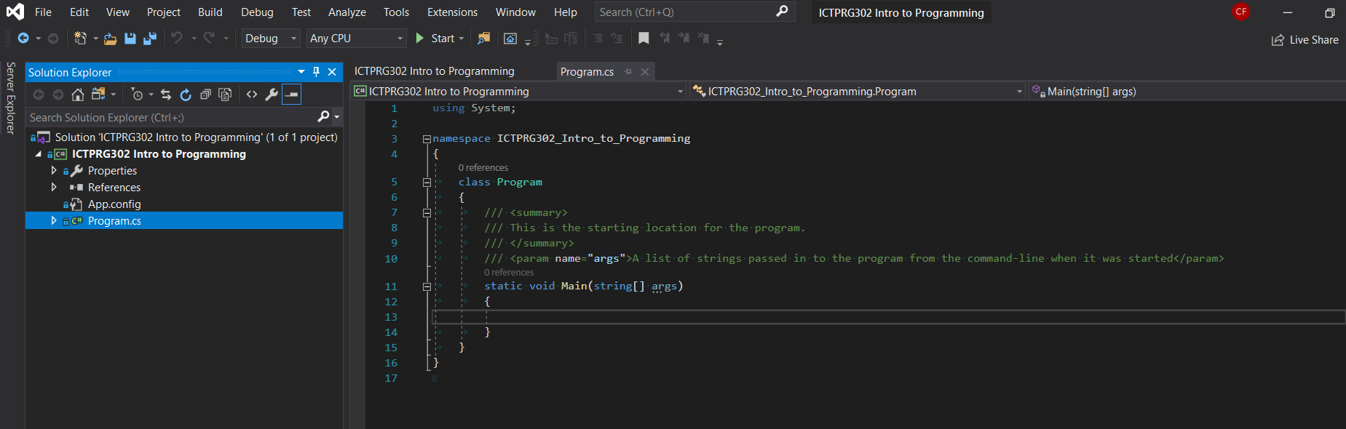

Console-based Program

Step 1 - Create a Gamertags class
We will create a new class (a user-defined datatype) to hold the related data and functions required to manage the list of gamertags.
The most important data this class will contain is the list of Gamertags. This will be stored in the class as an array of strings.
- Select the Project->Add Class menu item
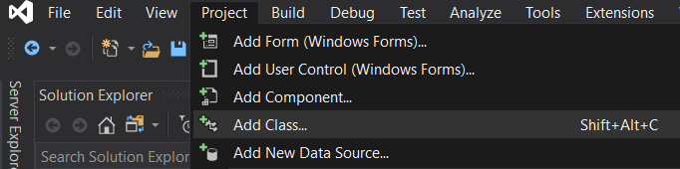
- Select a Basic C# Class type. Name the new class Gamertags.
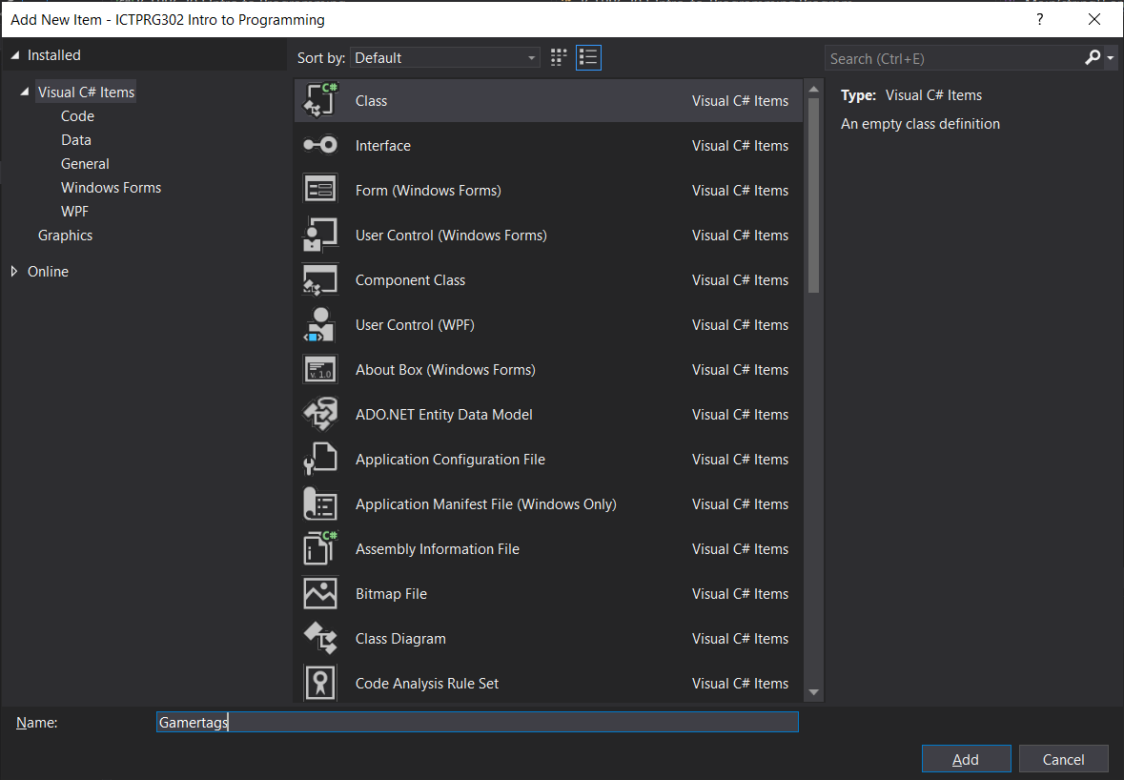
- Notice that a new file has been added to the project called Gamertags.cs and it’s immediately opened in the code editor tab. This is where we add our data/functions for this class.
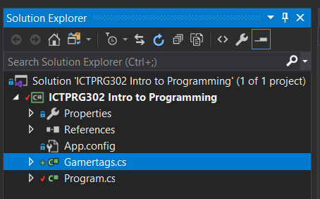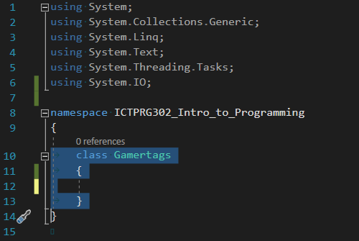
- Add a new private variable that will later be used to hold our list of gamer tags once they’re loaded from file. Optionally add a comment to help describe the class variable. The private keyword restricts access to data (other options public/protected).
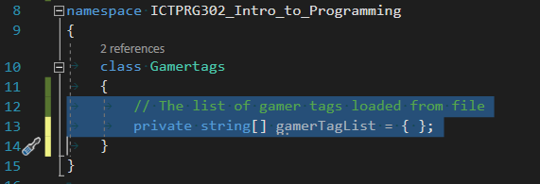

Step 2 - Loading the “Gamertags.txt” file via the Gamertags class
Functions add helpful operations to our classes that we can call/run/execute from elsewhere in our code. They contain a sequence of operations to process (in order). This can be as simple as a single instruction, or something more complex.
- Include the following using clause at the top of your file to allow the compiler to find the File class in a namespace called System.IO
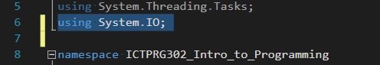
- Add a function called LoadGamertags to this class as follows:
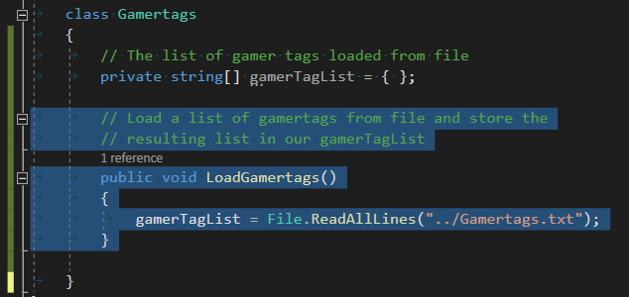
This will load a file called “Gamertags.txt” from disk and stores the data in the gamerTagList variable. The “../” asks the compiler to look for the file in the parent folder from where it starts up, which happens to be the “ICTPRG302 Intro to Programming\bin” folder.

Step 3 – Printing all available gamertags
We’ll add another function to loop over the list of gamertags and print each to the console one line at a time. We’ll print a header at the start. We’ll also wait for the user to press a key before continuing the program.
- Add a function called PrintAllGamertags to this class as follows:
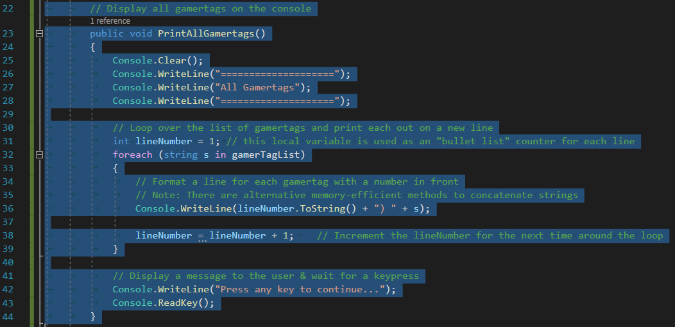
This function prints a 3-line header, loops over all the gamertags in the gamerTagList and prints each to a new line in the Console. Finally, it prints a message to the user and waits for the user to press any key before continuing.

Step 4 – Create an instance of the Gamertag class
Up to now, the class we’ve created hasn’t been “used” yet, and our program will not execute any functions we’ve written. This is because a class can be thought of as a blueprint. We need to create an instance of it (like making an object from any blueprint) and then use the instance in our program.
In the Program.cs file add the following code to create a new instance of the Gamertag class and store it in a local variable called gamertags.
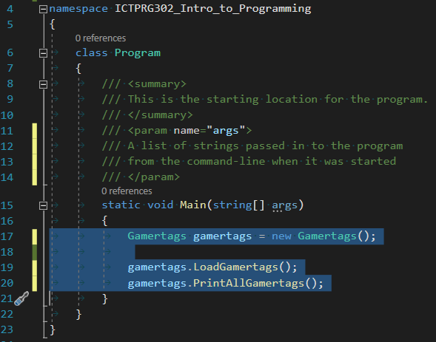
After creating an instance of the Gamertags class, our Main() function can call the public functions we created. We’ll call the functions in a sequence that makes sense.
Firstly, we want to load the gamertags from file.
Secondly, we want to display the loaded gamertags to the Console.
Note that the computer follows our commands in sequence, like instructions in a recipe, step-by-step.

Step 5 – Test your current progress
Build and run your program by pressing the Start  button in the Visual Studio toolbar. If there are syntax errors the compiler will display a message. For example, if you make a typo, you may see something like:
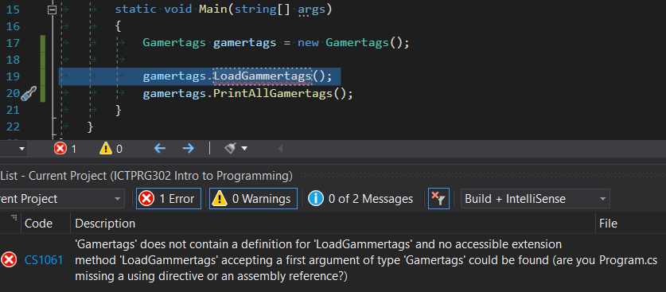
Double-click the error message to bring the error in to focus in the editor. Then make any necessary changes before trying again.
After all syntax errors have been fixed, Start your program. You should see the following output:


Step 6 – Filter and Display gamertags ending with a number
Add the following function to the Gamertags class that filters gamertags ending with a number and ignore all the others.
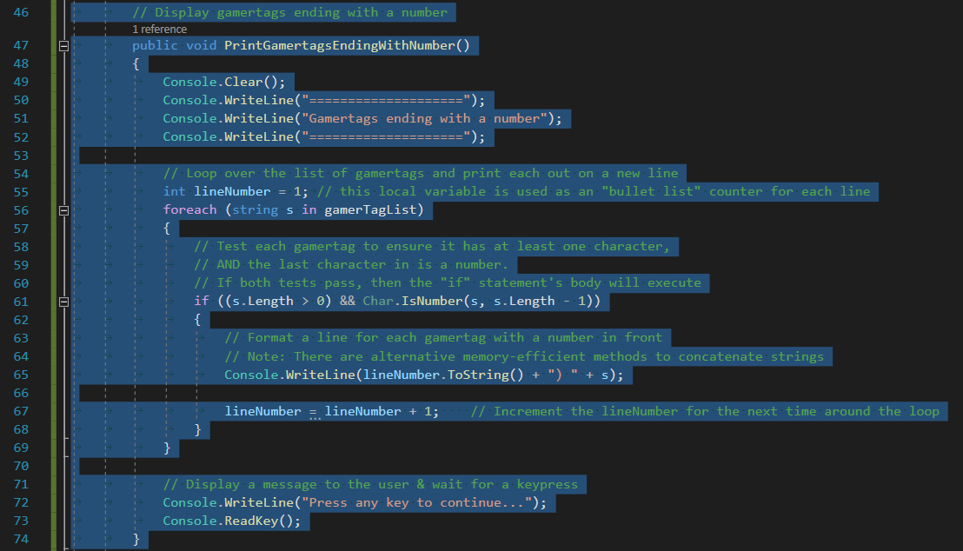
Note the “if statement” being used inside the “foreach loop”. We test each gamertag in the gamerTagList to ensure it has at least one character and the last character is a number. If both tests are valid then the if-body will be processed, and the program will print the gamertag.
You should see the following output:
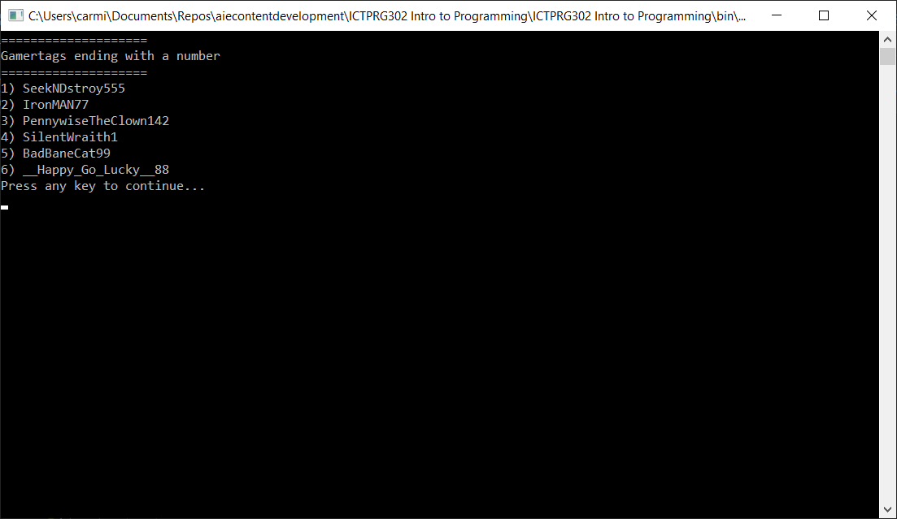

Step 7 - Filter and Display gamertags NOT starting with a “letter or number”
Add a function to the Gamertags class such that it will only display gamertags NOT starting with a letter or number.
Research the C# functions Char.IsLetterOrDigit() for more assistance:
- https://docs.microsoft.com/en-us/dotnet/api/system.char.isletterordigit?view=netcore-3.1
You should see output like the following:
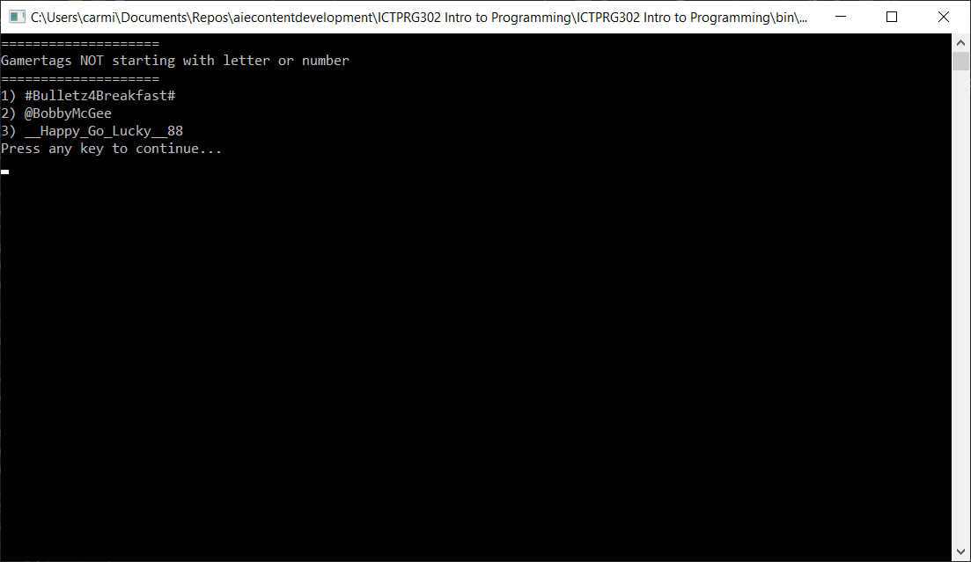

Step 8 – Display a Welcome Message
Using the previous steps and practice, create a new function “ShowWelcomeMessage()” that your program uses to display a formatted welcome screen similar to the following (feel free to use some creativity when designing your own) . Wait for the user to press a key before continuing with the rest of the program:
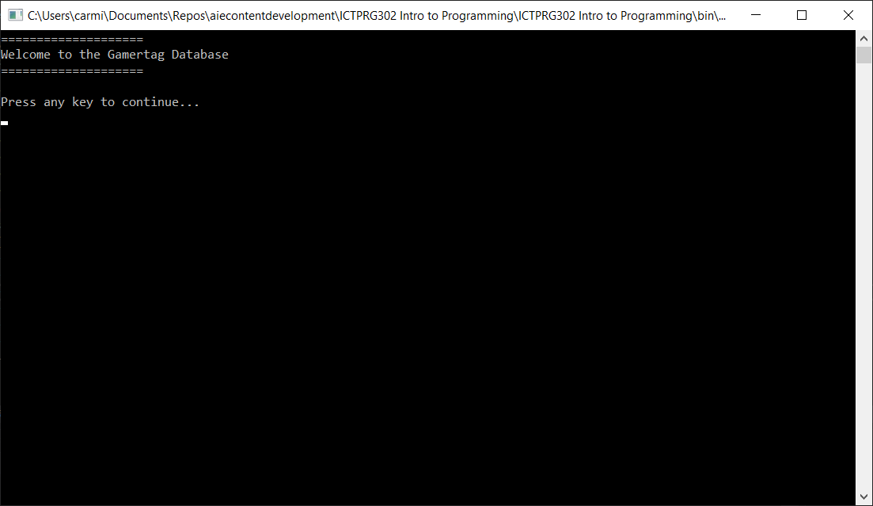

Step 9 – Processing user input
At present your program runs through its sequence once and terminates. What if your user wants to view the output again without having to re-run the program?
Update your Main() function with a while-loop that:
- Runs the sequence and output gamertags as previously
- Asks the user if they would like to view the output again
- Process the user’s input to rerun the sequence or quit the program
Here’s an example of a while-loop that asks the user whether to re-run the program:
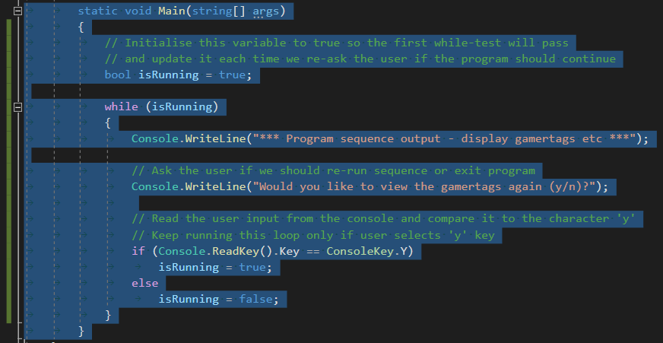

Step 10 (Optional) – Create other filters for gamertags
Extend your basic program to include other filters for the list of gamertags.
Examples include:
- Print all Gamertags that include only “letters or numbers”
- Print all Gamertags in “uppercase”
- Print the “first 5” Gamertags, ignoring the rest

Step 11 (Optional) – Getting creative
Think about ways that you can extend your basic program to include more user-interactivity.
Examples include:
- Adding a menu that responds to user-input. Allow the user to choose what to display.
- Adding new gamertags to the list, by asking the user for them to input a gamertag
- Saving the gamertags to file when the program ends (see File.WriteAllLines())

Debugging Exercise
The debugger is a powerful integrated tool in the Visual Studio Environment. It’s used to help programmers find and fix logic errors in their programs. These errors are colloquially called bugs.

Step 1 - Answer the following questions about debugger usage

What are breakpoints used for?
Breakpoints are used to pause the flow of execution of the programs at runtime to understand how the piece of code on a line acts and it’s atypical behaviour to be modified.

What Visual Studio windows/tab(s) are typically used to interrogate the values of a variable during a debugging session?
- Diagnostic Tools to report on resource usage
- Output messages to write the value of variables or other messages to the console or an external display.
- Debugging tool bar to help identity logic errors, monitor unknown behaviours etc..
- The watch, autos and locals windows are used when the program is paused, not closed to help inspect the values of variables: Watch windows will show the value of the variable you specify, Autos shows any variable used at least 3 lines before the current line, and locals will show the values of all local variables.
- Callstack window shows the functions that are currently on the stack, a good was to view which line of code has caused the crash

What is “stepping” through code?
Why do we do it?
How do we “step” through code whilst debugging?
Stepping through code is to help identify code line by line to see what line of code causes an error to happen.
we do it for step by step debugging so we can analyse what line of code is the problem instead of having the entirety of the code run at once, making stepping much easier but slower to do.
first we have to designate a breakpoint, we can “step into” the code to say that we want to go to that function, therefore it will, we can “step over” code to help the computer identify that if an execution pointer as at a function, don’t go to it, instead it will skip over it and continue to the next line, then there is “Step out” in code to execute the remainder of the function and return you to the next line after the original call.

Explain one situation during development of your application where the debugger was helpful? What was the problem you faced? How was the debugger helpful?
During coding and running the gamertag database, I ran into an error that explained an Unhandled Exception, this little debugger window identified that one of my directory preferences was typed out wrong, being how I wrote Gamertags.txt wrong, leading it to get nothing from a non-existent file name.

Final Testing
To verify the correct operation of your program, you must create, perform and document tests. The tests will assist in confirming that your program satisfies the original task description.

Step 1 – Perform the following tests and record the results

Step 2 – Fix any errors in your program before submitting your assignment

Confirm that your program outputs the following gamertags when “Printing ALL Gamertags” | TEST PASSED?
  SeekNDstroy555  #Bulletz4Breakfast#  BigDamnHero  laidtoRest  IronMAN77  Xenomorphing  TylerDurden  PennywiseTheClown142  BluntMachete  SniperLyfe  SilentWraith1  BloodyAssault  FightClubAlum  KillSwitch  ExecuteElectrocute  BadBaneCat99  IndominusRexxx  @BobbyMcGee  __Happy_Go_Lucky__88  AzogtheDefiler | YES

Confirm that your program displays the following when “Printing Gamertags Ending with a number” | TEST PASSED?
SeekNDstroy555    IronMAN77  PennywiseTheClown142  SilentWraith1  BadBaneCat99  __Happy_Go_Lucky__88 | YES

Confirm that your program displays the following when “Printing Gamertags NOT starting with a letter or number” | TEST PASSED?
  #Bulletz4Breakfast#  @BobbyMcGee  __Happy_Go_Lucky__88 | YES

